Pythonanywhere working: (because it has been falling over)

Main page ( home.html) this comes from the staticpages folder

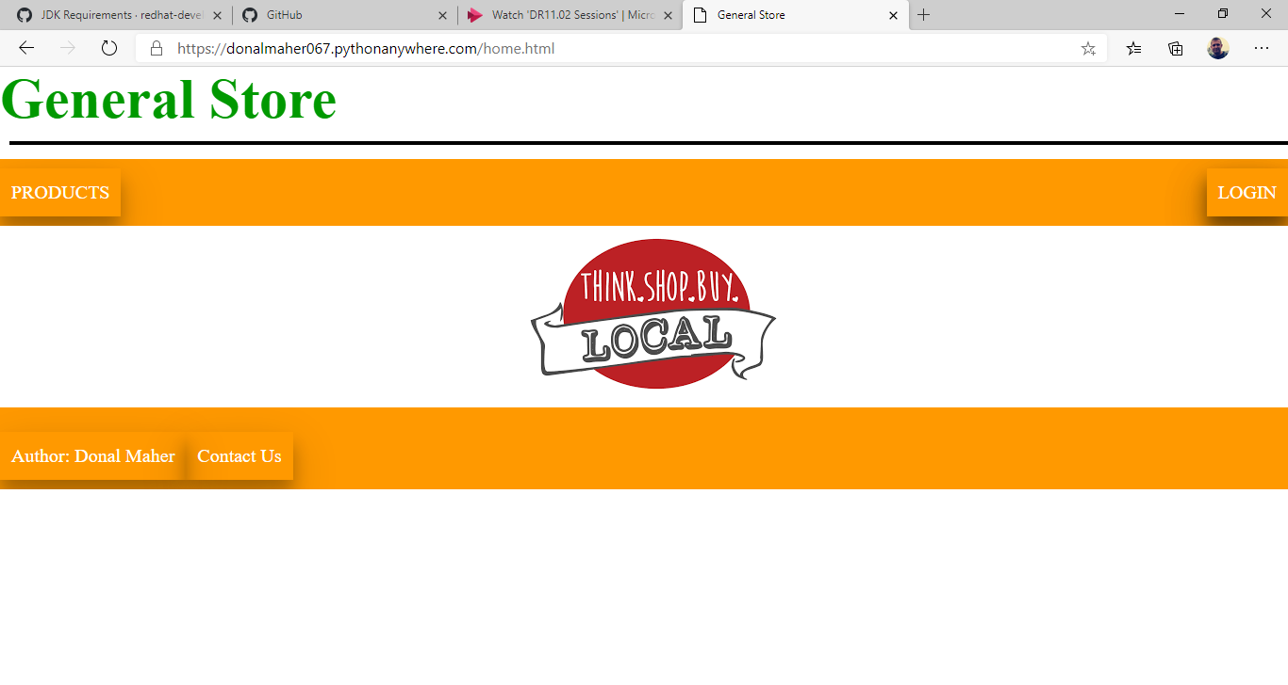

Products button: redirects to showProducts.html where the mysql database is select statement is showing the contents of the database.

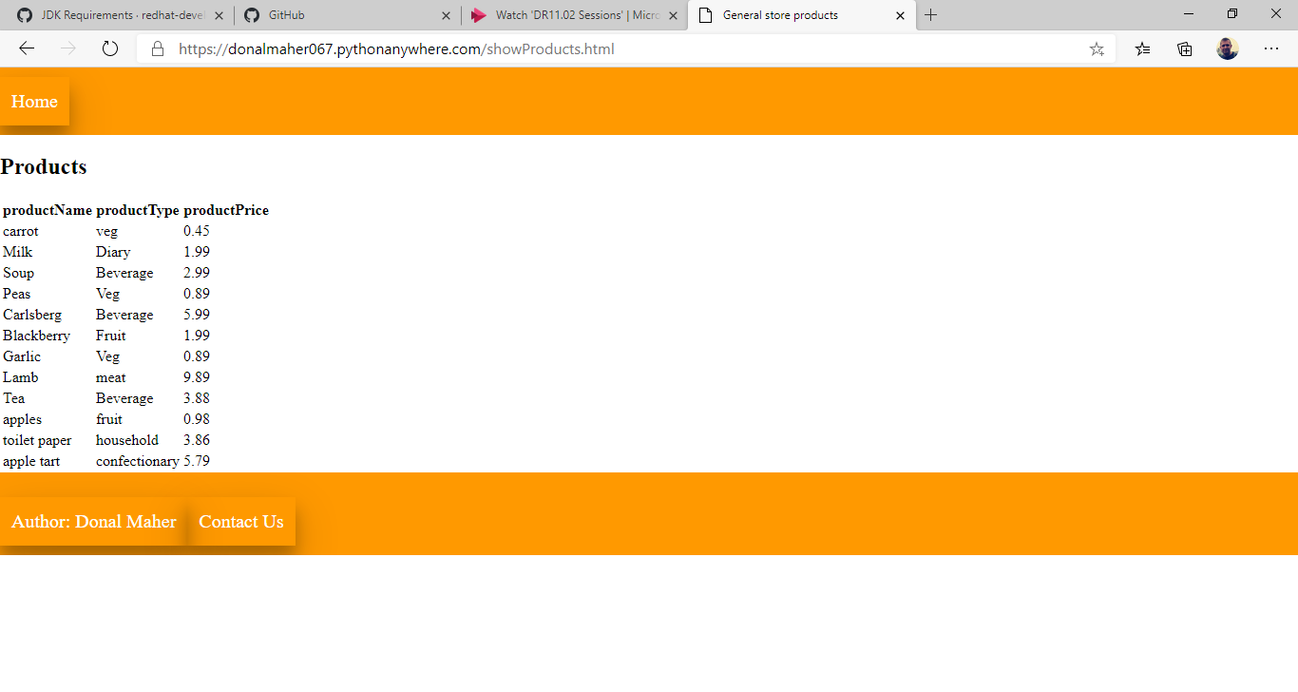

Back to the home.html where button click on the login button

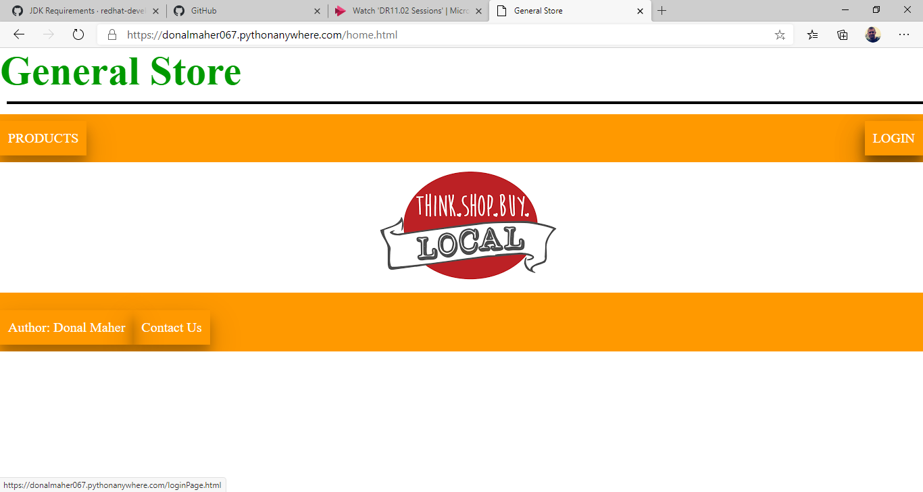

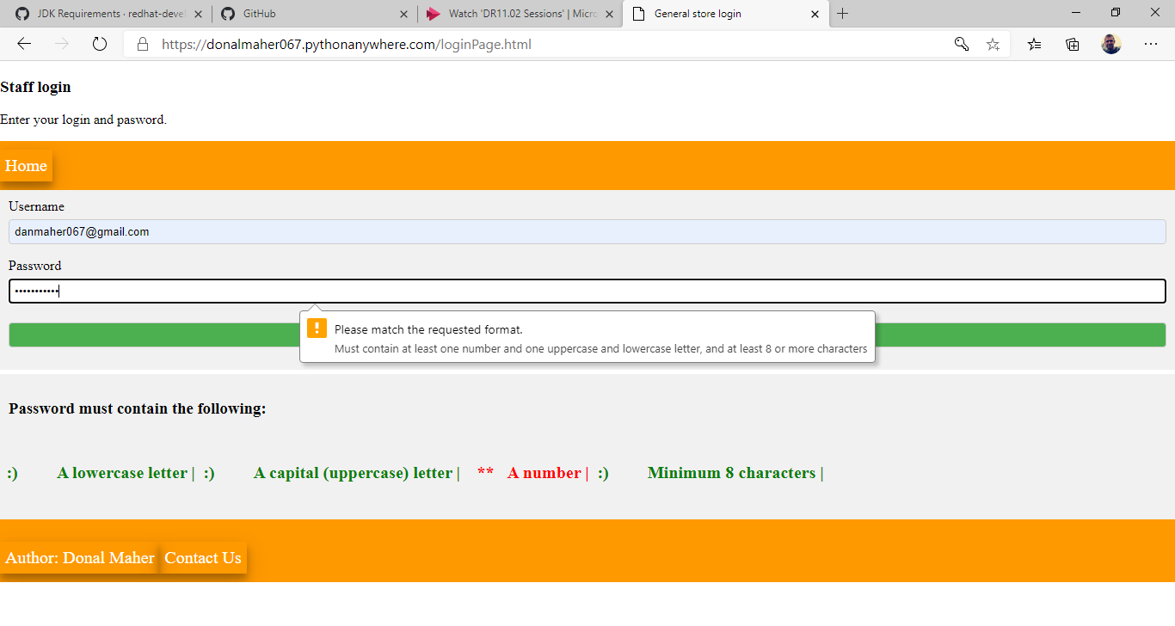

The login does not require any specific information, as long as you put in a name and the password passes the criteria.

Once submitted then brings to index.html where for example a shop employee would to CRUD operations on the stock.

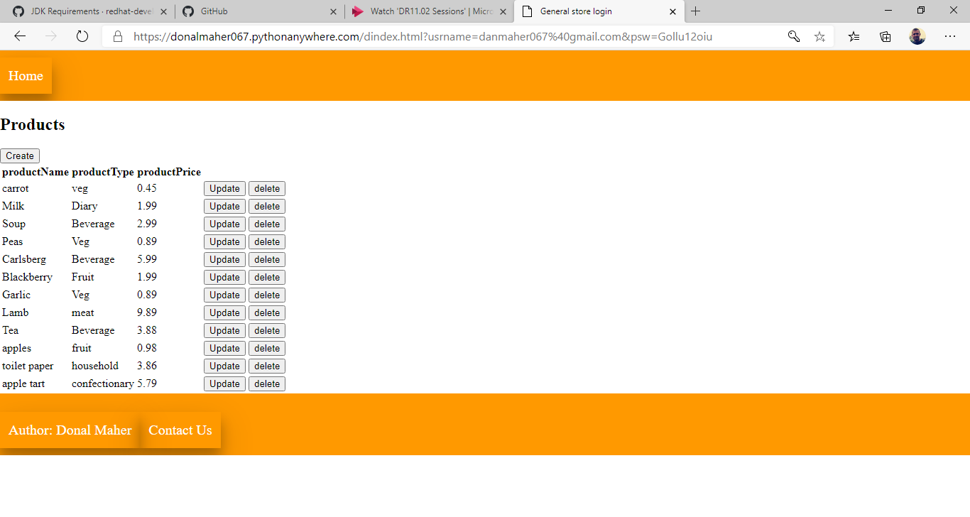

Create:

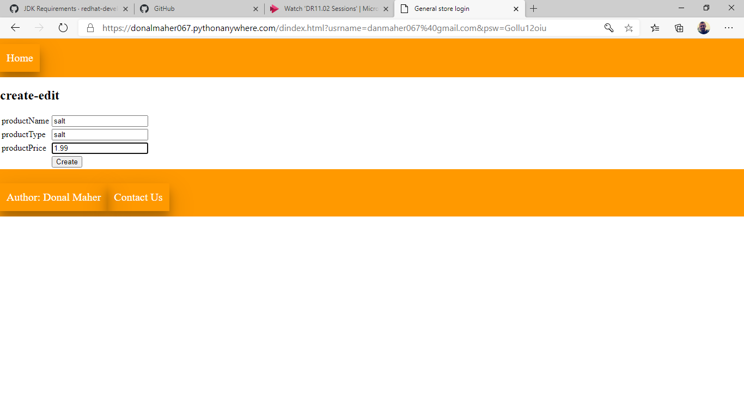

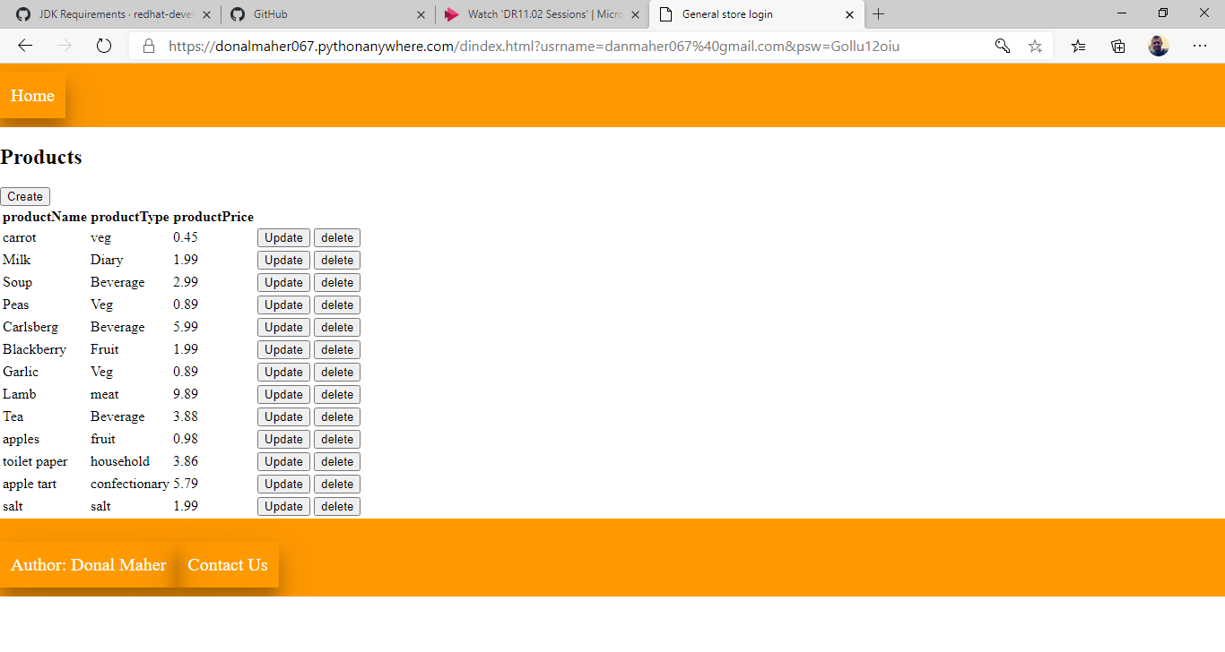

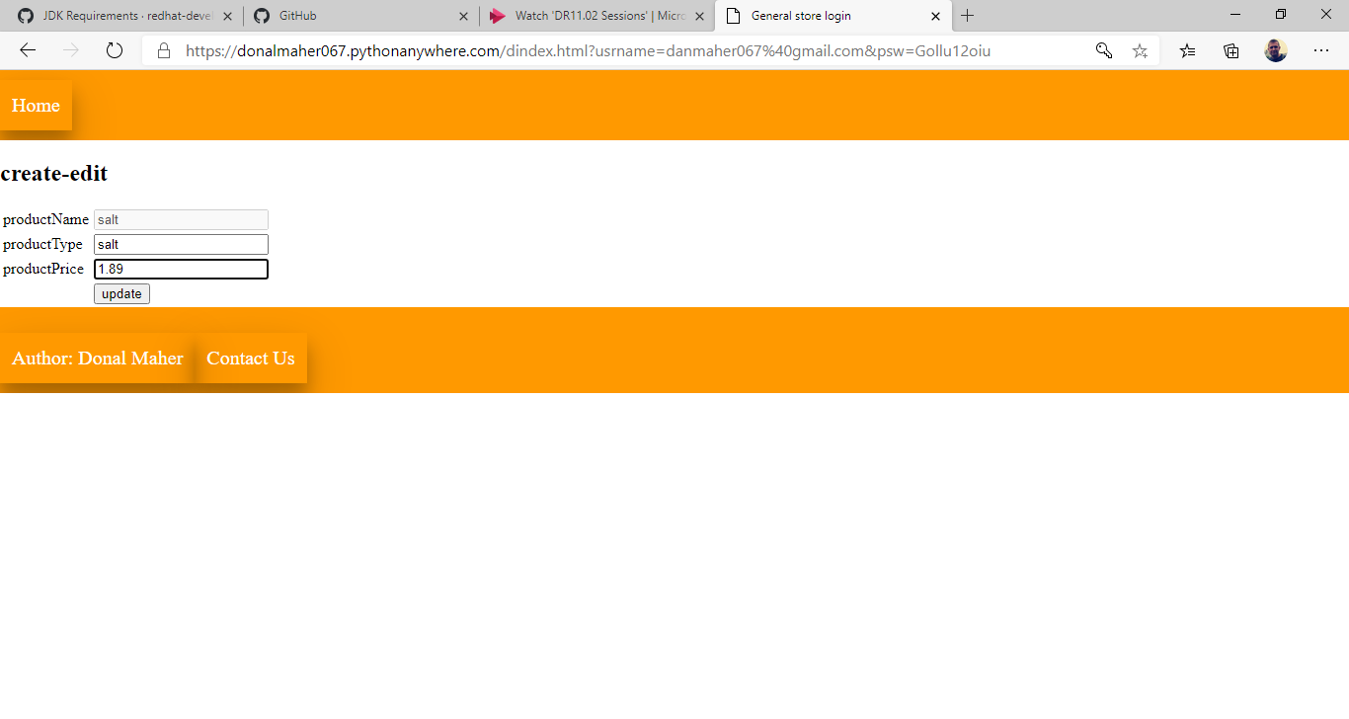

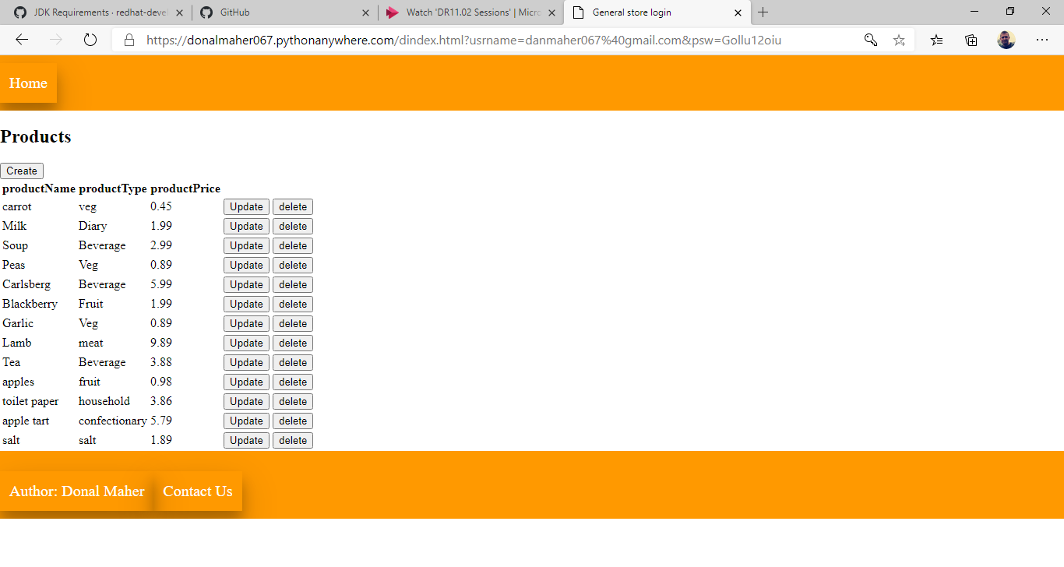

Delete:

